**Digital signals**

As compared to analog signals, digital signals are very easy to analyze. They are discontinuous signals. They are the appropriation of analog signals.

The word digital stands for discrete values and hence it means that they use specific values to represent any information. In digital signal, only two values are used to represent something i-e: 1 and 0 (binary values). Digital signals are less accurate then analog signals because they are the discrete samples of an analog signal taken over some period of time. However digital signals are not subject to noise. So they last long and are easy to interpret. Digital signals are denoted by square waves.

For example:

Computer keyboard

Whenever a key is pressed from the keyboard, the appropriate electrical signal is sent to keyboard controller containing the ASCII value that particular key. For example the electrical signal that is generated when keyboard key a is pressed, carry information of digit 97 in the form of 0 and 1, which is the ASCII value of character a

**Digital Signals**

In our daily lives, analog signals appear as speech, audio, seismic, biomedical, and communications signals. To process an analog signal using a digital signal processor, the analog signal must be converted into a digital signal; that is, analog-to-digital conversion (ADC) must take place, as discussed in Chapter 2. Then the digital signal is processed via digital signal processing (DSP) algorithm(s).

A typical digital signal *x*( *n*) is shown in Figure 3.1, where both the time and the amplitude of the digital signal are discrete. Notice that the amplitudes of digital signal samples are given and sketched only at their corresponding time indices, where *x*( *n*) represents the amplitude of the *n*th sample and *n* is the time index or sample number. From Figure 3.1, we learn that

* *x*(0): zero-th sample amplitude at the sample number *n =* 0,
* *x*(1) *:* first sample amplitude at the sample number *n =* 1,
* *x*(2) *:* second sample amplitude at the sample number *n =*2,
* *x*(3): third sample amplitude at the sample number *n =* 3, and so on.

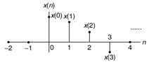  
Figure 3.1: Digital signal notation.

Furthermore, Figure 3.2 illustrates the digital samples...

Difference between analog and digital signals

|  |  |  |
| --- | --- | --- |
| **Comparison element** | **Analog signal** | **Digital signal** |
| Analysis | Difficult | Possible to analyze |
| Representation | Continuous | Discontinuous |
| Accuracy | More accurate | Less accurate |
| Storage | Infinite memory | Easily stored |
| Subject to Noise | Yes | No |
| Recording Technique | Original signal is preserved | Samples of the signal are taken and preserved |
| Examples | Human voice, Thermometer, Analog phones e.t.c | Computers, Digital Phones, Digital pens, e.t.c |

## Systems

A system is a defined by the type of input and output it deals with. Since we are dealing with signals, so in our case, our system would be a mathematical model, a piece of code/software, or a physical device, or a black box whose input is a signal and it performs some processing on that signal, and the output is a signal. The input is known as excitation and the output is known as response.

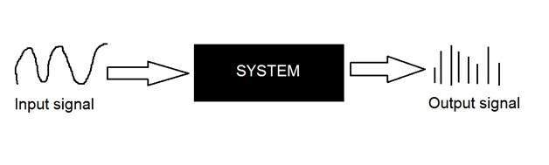

In the above figure a system has been shown whose input and output both are signals but the input is an analog signal. And the output is an digital signal. It means our system is actually a conversion system that converts analog signals to digital signals.

## Lets have a look at the inside of this black box system

## Conversion of analog to digital signals

Since there are lot of concepts related to this analog to digital conversion and vice-versa. We will only discuss those which are related to digital image processing.There are two main concepts that are involved in the coversion.

* Sampling
* Quantization

### **Sampling**

Sampling as its name suggests can be defined as take samples. Take samples of a digital signal over x axis. Sampling is done on an independent variable. In case of this mathematical equation:

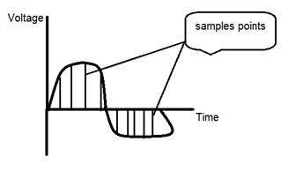

Sampling is done on the x variable. We can also say that the conversion of x axis (infinite values) to digital is done under sampling.

Sampling is further divide into up sampling and down sampling. If the range of values on x-axis are less then we will increase the sample of values. This is known as up sampling and its vice versa is known as down sampling.

### **Quantization**

Quantization as its name suggest can be defined as dividing into quanta (partitions). Quantization is done on dependent variable. It is opposite to sampling.

In case of this mathematical equation y = sin(x)

Quantization is done on the Y variable. It is done on the y axis. The conversion of y axis infinite values to 1, 0, -1 (or any other level) is known as Quantization.

These are the two basics steps that are involved while converting an analog signal to a digital signal.

The quantization of a signal has been shown in the figure below.

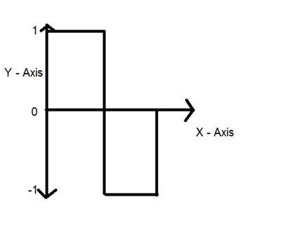

## *Why do we need to convert an analog signal to digital signal.*

The first and obvious reason is that digital image processing deals with digital images, that are digital signals. So when ever the image is captured, it is converted into digital format and then it is processed.

The second and important reason is, that in order to perform operations on an analog signal with a digital computer, you have to store that analog signal in the computer. And in order to store an analog signal, infinite memory is required to store it. And since thats not possible, so thats why we convert that signal into digital format and then store it in digital computer and then performs operations on it.

## Continuous systems vs discrete systems

### **Continuous systems**

The type of systems whose input and output both are continuous signals or analog signals are called continuous systems.

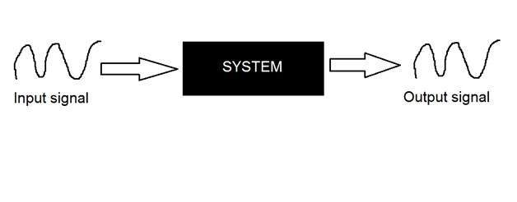

### **Discrete systems**

The type of systems whose input and output both are discrete signals or digital signals are called digital systems.

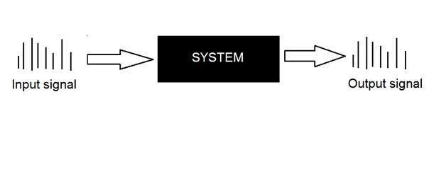

**Digital signal modulation techniques**

## Digital modulation

In order to transmit [computer](https://www.britannica.com/technology/computer) data and other digitized information over a communications channel, an analog carrier wave can be modulated to reflect the binary nature of the digital baseband signal. The [parameters](https://www.merriam-webster.com/dictionary/parameters) of the carrier that can be modified are the amplitude, the frequency, and the phase.

## Amplitude-shift keying

If amplitude is the only [parameter](https://www.merriam-webster.com/dictionary/parameter) of the carrier wave to be altered by the information signal, the modulating method is called amplitude-shift keying (ASK). ASK can be considered a digital version of analog amplitude modulation. In its simplest form, a burst of radio frequency is transmitted only when a binary 1 appears and is stopped when a 0 appears. In another variation, the 0 and 1 are represented in the modulated signal by a shift between two preselected amplitudes.

## Frequency-shift keying

If frequency is the parameter chosen to be a function of the information signal, the modulation method is called frequency-shift keying (FSK). In the simplest form of FSK signaling, digital [data](https://www.britannica.com/dictionary/data) is transmitted using one of two frequencies, whereby one frequency is used to transmit a 1 and the other frequency to transmit a 0.

## Phase-shift keying

When phase is the parameter altered by the information signal, the method is called phase-shift keying (PSK). In the simplest form of PSK, a single radio frequency carrier is sent with a fixed phase to represent a 0 and with a 180° phase shift—that is, with the opposite polarity—to represent a 1.

In addition to the elementary forms of digital modulation described above, there exist more-advanced methods that result from a superposition of multiple modulating signals. An example of the latter form of modulation is quadrature [amplitude](https://www.britannica.com/dictionary/amplitude) modulation (QAM). QAM signals actually transmit two amplitude-modulated signals in phase quadrature (i.e., 90° apart), so that four or more bits are represented by each shift of the combined signal.

## [Pulse modulation](https://www.britannica.com/technology/pulse-coded-modulation)

In pulse modulation, a series of on-off pulses serve as the carrier wave that is subsequently modulated. In pulse-coded modulation (PCM), the information signal converts the carrier into a series of constant-amplitude pulses spaced in such a manner that the desired intelligence is contained in coded form. PCM minimizes transmission losses and eliminates noise and interference problems because the receiving unit need only detect and identify simple pulse patterns. PCM is used for digital audio in computers and in [compact discs](https://www.britannica.com/technology/compact-disc), [DVDs](https://www.britannica.com/technology/DVD), and [Blu-Ray](https://www.britannica.com/technology/Blu-ray) discs. Another kind of pulse modulation is pulse-duration modulation (PDM), in which intelligence is represented by the length and order of regularly recurring pulses.

***The most fundamental digital modulation techniques are based on***[***keying***](https://en.wikipedia.org/wiki/Keying_(telecommunications))***:***

* [PSK (phase-shift keying)](https://en.wikipedia.org/wiki/Phase-shift_keying): a finite number of phases are used.
* [FSK (frequency-shift keying)](https://en.wikipedia.org/wiki/Frequency-shift_keying): a finite number of frequencies are used.
* [ASK (amplitude-shift keying)](https://en.wikipedia.org/wiki/Amplitude-shift_keying): a finite number of amplitudes are used.
* [QAM (quadrature amplitude modulation)](https://en.wikipedia.org/wiki/Quadrature_amplitude_modulation): a finite number of at least two phases and at least two amplitudes are used.

**Basic Digital Modulation Techniques**

**Amplitude Shift Keying (ASK)**

In this method signal level is represented by variations in the amplitude of the signal. In ASK only the amplitude is varied keeping phase and frequency constant.

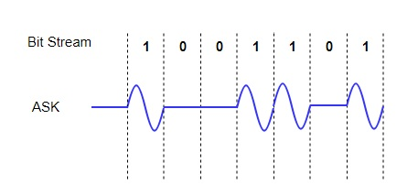

**Frequency Shift Keying (FSK)**

In this method also signal level is represented by variations in the frequency of the signal. In FSK only the frequency is varied keeping amplitude and phase constant. We then use different frequency levels to show the signal levels 0 and 1.

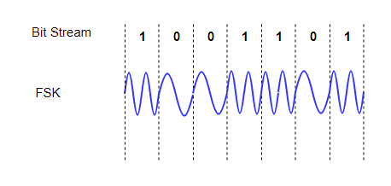

**Phase Shift Keying (PSK)**

The variation in phase of the signal in this method represents the signal level. In PSK only the frequency is varied keeping amplitude and frequency constant. Also we use different phases to show the signal levels 0 and 1.

The basic and simple form of PSK is Binary Phase Shift Keying (BPSK). In this [modulation](https://en.wikipedia.org/wiki/Modulation) two different phases represent the two signals. Another method in PSK is Quadrature PSK (QPSK). In this method four different phases then transmit two bits of information.

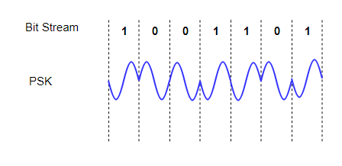

**MSK**

For converting digital signals to analog signals we use this technique. There is delay in Q component in this method. Then the delay is equal to half of the symbol period. In MSK encoding is in alternating bits which are between the quadrature components. Also it is the most efficient and easy technique amongst all the above techniques. Its implementation is easy compared to PSK, FSK and ASK.

* Basically, the position of even and odd bits for a given bit stream are important along with their bit positions frequency table.
* Also, this method can manage the variation of bits from 1 to 0 very easily and efficiently. Hence, they are used widely compared to other techniques.
* **DIGITAL FILTERS**
* Digital filtering involves passing analog data to a processor that then runs code to digitally filter the data.
* **Digital Filtering Advantages**
* The advantages to digital filtering are numerous. The most apparent is that digital filters require less hardware, as they are done on a processor. This makes them very versatile and applicable in any system with a processor. In addition to lowering the cost, extra hardware has the added disadvantages of being affected by external factors such as temperature, humidity, and general wear and tear. Advanced and specialized filters can be applied to data, so long as the processing power exists to perform the filtering methods. Digital filters are software programmable, which
* ***Disadvantages***
* The standard disadvantage of a digital filter is that digital filters are significantly slower than analog filters (Smith). Digital filters introduce additional latency into a system, as the analog data that comes out of the hardware must be processed on a computer before it is filtered as desired. It is also difficult handle large frequency ranges with digital filters. The sampling rate to capture one cycle at 0.01 Hz must be extremely high (20 million points). This is a very large amount of data for just one cycle, let alone multiple.

**DIGITAL DEMODULATION**

**Demodulation** is extracting the original information-bearing [signal](https://en.wikipedia.org/wiki/Signal) from a [carrier wave](https://en.wikipedia.org/wiki/Carrier_wave). A **demodulator** is an [electronic circuit](https://en.wikipedia.org/wiki/Electronic_circuit) (or [computer program](https://en.wikipedia.org/wiki/Computer_program) in a [software-defined radio](https://en.wikipedia.org/wiki/Software-defined_radio)) that is used to recover the information content from the modulated carrier wave.[[1]](https://en.wikipedia.org/wiki/Demodulation#cite_note-1) There are many types of [modulation](https://en.wikipedia.org/wiki/Modulation) so there are many types of demodulators. The signal output from a demodulator may represent sound (an [analog](https://en.wikipedia.org/wiki/Analog_signal) [audio signal](https://en.wikipedia.org/wiki/Audio_signal)), images (an analog [video signal](https://en.wikipedia.org/wiki/Video_signal)) or [binary](https://en.wikipedia.org/wiki/Binary_signal) data (a [digital signal](https://en.wikipedia.org/wiki/Digital_signal_(electronics))).

* These terms are traditionally used in connection with [radio receivers](https://en.wikipedia.org/wiki/Radio_receiver), but many other systems use many kinds of demodulators. For example, in a [modem](https://en.wikipedia.org/wiki/Modem), which is a contraction of the terms [modulator](https://en.wikipedia.org/wiki/Modulator)/demodulator, a demodulator is used to extract a serial digital data stream from a [carrier signal](https://en.wikipedia.org/wiki/Carrier_signal) which is used to carry it through a [telephone line](https://en.wikipedia.org/wiki/Telephone_line), [coaxial cable](https://en.wikipedia.org/wiki/Coaxial_cable), or [optical fiber](https://en.wikipedia.org/wiki/Optical_fiber).

*Demodulation is the process of restoring the data bits back from a digitally modulated signal.*

## Demodulation Techniques

There are several ways of demodulation depending on how parameters of the base-band signal such as amplitude, frequency or phase are transmitted in the carrier signal. For example, for a signal modulated with a linear modulation like AM ([amplitude modulation](https://en.wikipedia.org/wiki/Amplitude_modulation)), we can use a [synchronous detector](https://en.wikipedia.org/wiki/Synchronous_detector). On the other hand, for a signal modulated with an angular modulation, we must use an FM ([frequency modulation](https://en.wikipedia.org/wiki/Frequency_modulation)) demodulator or a PM ([phase modulation](https://en.wikipedia.org/wiki/Phase_modulation)) demodulator. Different kinds of circuits perform these functions.

Many techniques such as [carrier recovery](https://en.wikipedia.org/wiki/Carrier_recovery), [clock recovery](https://en.wikipedia.org/wiki/Clock_recovery), [bit slip](https://en.wikipedia.org/wiki/Bit_slip), [frame synchronization](https://en.wikipedia.org/wiki/Frame_synchronization), [rake receiver](https://en.wikipedia.org/wiki/Rake_receiver), [pulse compression](https://en.wikipedia.org/wiki/Pulse_compression), [Received Signal Strength Indication](https://en.wikipedia.org/wiki/Received_Signal_Strength_Indication), [error detection and correction](https://en.wikipedia.org/wiki/Error_detection_and_correction), etc., are only performed by demodulators, although any specific demodulator may perform only some or none of these techniques.

Many things can act as a demodulator, if they pass the radio waves on [nonlinearly](https://en.wikipedia.org/wiki/Nonlinear)

***AM radio***

An [AM](https://en.wikipedia.org/wiki/Amplitude_modulation) signal encodes the information into the carrier wave by varying its amplitude in direct sympathy with the [analogue signal](https://en.wikipedia.org/wiki/Analog_signal) to be sent. There are two methods used to [demodulate AM signals](https://en.wikipedia.org/wiki/Detector_(radio)):

* The [**envelope detector**](https://en.wikipedia.org/wiki/Envelope_detector) is a very simple method of demodulation that does not require a [coherent](https://en.wikipedia.org/wiki/Coherence_(physics)) demodulator. It consists of an [envelope detector](https://en.wikipedia.org/wiki/Envelope_detector) that can be a [rectifier](https://en.wikipedia.org/wiki/Rectifier) (anything that will pass current in one direction only) or other non-linear component that enhances one half of the received signal over the other and a low-pass filter. The rectifier may be in the form of a single [diode](https://en.wikipedia.org/wiki/Diode) or may be [more complex](https://en.wikipedia.org/wiki/Plate_detector_(radio)). Many natural substances exhibit this rectification behaviour, which is why it was the earliest modulation and demodulation technique used in radio. The filter is usually an [RC](https://en.wikipedia.org/wiki/RC_circuit) [low-pass](https://en.wikipedia.org/wiki/Low-pass_filter) type but the filter function can sometimes be achieved by relying on the limited frequency response of the circuitry following the rectifier. The [crystal set](https://en.wikipedia.org/wiki/Crystal_radio_receiver) exploits the simplicity of AM modulation to produce a receiver with very few parts, using the crystal as the rectifier and the limited frequency response of the headphones as the filter.
* The [**product detector**](https://en.wikipedia.org/wiki/Product_detector) multiplies the incoming signal by the signal of a local oscillator with the same frequency and phase as the carrier of the incoming signal. After filtering, the original audio signal will result.

[SSB](https://en.wikipedia.org/wiki/Single-sideband_modulation) is a form of AM in which the [carrier is reduced or suppressed entirely](https://en.wikipedia.org/wiki/Suppressed_carrier), which require coherent demodulation. For further reading, see [sideband](https://en.wikipedia.org/wiki/Sideband).

***FM radio***

[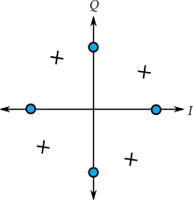](https://en.wikipedia.org/wiki/File:QPSK_Phase_Error.svg)

Example of [QPSK](https://en.wikipedia.org/wiki/QPSK) [carrier recovery](https://en.wikipedia.org/wiki/Carrier_recovery) **phase error** causing a fixed rotational offset of the received symbol [constellation](https://en.wikipedia.org/wiki/Constellation_diagram), X, relative to the intended constellation, O.

[Frequency modulation](https://en.wikipedia.org/wiki/Frequency_modulation) (FM) has numerous advantages over AM such as better fidelity and noise immunity. However, it is much more complex to both modulate and demodulate a carrier wave with FM, and AM predates it by several decades.

*There are several common types of FM demodulators:*

* The [quadrature detector](https://en.wikipedia.org/wiki/Detector_(radio)#Quadrature_detector), which [phase](https://en.wikipedia.org/wiki/Phase_(waves)) shifts the signal by 90 degrees and multiplies it with the unshifted version. One of the terms that drops out from this operation is the original information signal, which is selected and amplified.
* The signal is fed into a [PLL](https://en.wikipedia.org/wiki/Phase-locked_loop) and the error signal is used as the demodulated signal.
* The most common is a [Foster–Seeley discriminator](https://en.wikipedia.org/wiki/Foster%E2%80%93Seeley_discriminator). This is composed of an [electronic filter](https://en.wikipedia.org/wiki/Electronic_filter) which decreases the amplitude of some frequencies relative to others, followed by an AM demodulator. If the filter response changes linearly with frequency, the final analog output will be proportional to the input frequency, as desired.
* A variant of the Foster–Seeley discriminator called the [ratio detector](https://en.wikipedia.org/wiki/Detector_(radio)#Ratio_detector)[[3]](https://en.wikipedia.org/wiki/Demodulation#cite_note-3)
* Another method uses two AM demodulators, one tuned to the high end of the band and the other to the low end, and feed the outputs into a difference amplifier.[[*citation needed*](https://en.wikipedia.org/wiki/Wikipedia:Citation_needed)]
* Using a [digital signal processor](https://en.wikipedia.org/wiki/Digital_signal_processor), as used in [software-defined radio](https://en.wikipedia.org/wiki/Software-defined_radio).

***PM***

[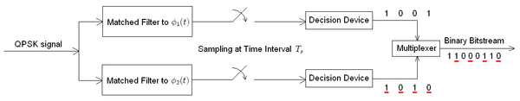](https://en.wikipedia.org/wiki/File:Receiver_QPSK.PNG)Receiver structure for QPSK. The matched filters can be replaced with correlators. Each detection device uses a reference threshold value to determine whether a 1 or 0 is detected.

***QAM***

QAM demodulation requires a coherent receiver.

**Basic structures of digital communication systems**

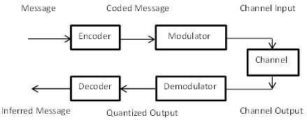

## Digital Communication System

A digital communication system refers to data transmission from one place to another. It is the communication between the sender and receiver. A sender is also known as **transmitter** that transmits the data. A communication channel between the transmitter and receiver acts as intermediate source to carry the information to the receiver

***The block diagram of a digital communication system is shown below:***

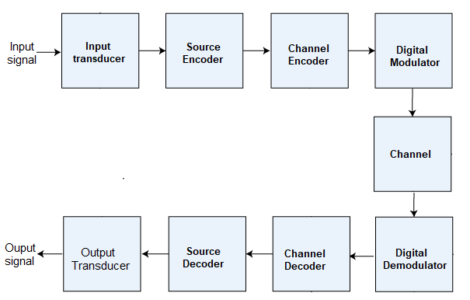

It consists of an **input transducer, source encoder, channel encoder, digital modulator, communication channel, digital demodulator, channel decoder, source decoder**, and **output transducer** connected in series. Let's discuss the function of each component in the digital communication system.

### **Source signal**

The source signal refers to the input signal applied to the digital communication system. It is also known as the input signal. Digital communication is generally used as a conversion system from analog to digital. Thus, the input signal is generally an **analog signal.** It can be analog or digital. In case of the analog signal as the input source signal, the digital communication system also works as an analog to digital converter by converting the analog input to the digital output.

### **Input Transducer**

The transducer is a device used to convert one form of energy to another. In a communication system, it converts the non-electrical energy to electrical energy to make it suitable for transmission within the system. In the case of the analog input, the block also contains an ADC (Analog to digital converter) to convert analog to the digital signal for further processing.

### **Source Encoder**

The source encoder compresses the data to the reduced number of bits from the original bits. It helps in effective bandwidth utilization and also removes unnecessary bits. It means that the compressed data is in the form of binary digits. We can also say that the source encoder converts the waveforms to binary data. The output data is further passed to the channel encoder.

### **Channel Encoder**

The information in the signal may get altered due to the noise during the transmissions. The channel encoder works as an error correction method. It adds redundant bits to the binary data that helps in correcting the error bits. It enhances the transmission quality of the signal and the channel.

### **Digital Modulator**

A carrier signal modulates the received signal. It modulates the digital by varying the transmitted signal's frequency, amplitude, and phase.

#### **Communication channel**

The communication channel is the medium between the transmitter and the receiver. It helps in transmitting a digital signal from the transmitter to the receiver. The data rate of the channel is measured in bits per second. The various types of channels in a digital communication system are **email, project management apps,** and **Intranet**.

### **Digital Demodulator**

The signal is demodulated and the source signal is recovered from the carrier signal.

### **Channel decoder**

The function of the channel encoder is to add the redundant bits to the binary data, as discussed above. The channel decoder works in the same but opposite way. It removes the parity bits from the binary data. It does not affect the signal quality and the information and transmits the data securely. The output of the channel decoder is a pure digital signal with no interference or noise.

### **Source decoder**

The source encoder works oppositely as that of the source encoder. It converts the binary data back to the waveforms.

### **Output Transducer**

The output transducer works in the opposite was as that of the input transducer. It converts the electrical energy back into its original form. It makes the information suitable for the user at the output to capture. The conversion is essential at both the ends of the communication system to make the system operate at a faster rate.

### **Output signal**

The output signal refers to the output from the digital communication system. It is the signal that appears at the output after passing through various communication system components. The output signal is only **a digital** signal.

### **Noise removal components**

Noise in the system can cause information loss and distortion. Hence, it is essential to use the noise removal components in the communication system. The noise removal components are used at both the transmitting and receiving ends to filter out the noise components from the signal. The noise components include anti-aliasing filters, shielded cables, and grounding concepts. The grounding acts as a reference voltage for the circuit and helps in preventing coupling.

### **Function of the digital communication system**

We have already discussed about each component in detail. Let's discuss how the data from one end through the transducer is transmitted to the receiving end. It makes the data available to the receiver without any noise or distortion. Here, we will discuss an example of the **video signal**.

The videos signal is first applied to the **input transducer** that converts the signal into the electrical form. The source **encoder** compresses the data to the reduced number of bits and the **channel encoder** removes the error by adding the redundant bits to the input digital data. It helps in encoding the signal into binary digit or seven digits PCM (Pulse Code Modulation). These are also used to represent the original video signal.

The **modulator** modulates the signal by varying the amplitude, frequency, or phase of the transmitted signal. The transmitted signal passes through the communication channel to reach the receiver. At the receiving end, the **demodulator** helps in recovering the message signal from the carrier. The **channel decoder, source decoder**, and the **output transducer** convert the digital signal into its original form of transmission. The output signal is a digital signal with no interference, noise, and error and is suitable for the user to capture.

## *Advantages of Digital Communication*

The advantages of digital communication are as follows:

* It is fast, more accurate, and more reliable than analog communication.
* The data with the help of digital communication can be quickly transmitted upto long distances.
* The detection and correction of errors is easy.
* It allows easy removal of noise, cross-talk, or any interference in the signal.
* It is inexpensive due to advanced technologies and compact size.
* The transmission speed of signal is high.
* It facilitates video and audio conferencing, allowing quick meetings and discussion with several people. It saves time and effort.

## *Disadvantages of Digital Communication*

The disadvantages of digital communication are as follows:

* **High power consumption**  
  It consumes high power due to the requirement of greater number of components, higher bandwidth, and high transmission speed.
* **High transmission bandwidth**  
  Digital communication requires high transmission bandwidth to transmit the signals at high speed.
* **High power loss**  
  The power loss in digital communication is higher than analog communication due to the high processing speed and hardware components.

## *Applications of Digital Communication*

There are various applications of digital communication ranging from small digital clocks to large industrial instruments. Let's discuss some of the most common applications of digital communication.

* Image and video processing
* Data compression
* Channel coding
* Equalization
* Digital Signal Processing
* Speech processing
* Satellites
* Digital audio transmission

## Digital vs. Analog

The digital computers were the first technologies used to store the digital record with a large size occupying the space of a room. The later inventions created new history and today digital computers are used to store millions of data with a size similar to rice grain.

The differences between digital communication and analog communication are listed in the below table:

|  |  |  |
| --- | --- | --- |
| **Category** | **Digital Communication** | **Analog Communication** |
| **Definition** | It uses digital signals with discrete values for transmitting data represented in the form of two binary digits 0 and 1. | It uses analog signals for transmitting data. |
| **Signal** | The digital signal represents one bit at a time. | The analog signal represents continuous values at a time. |
| **Noise Immunity** | Good | Poor |
| **Error Probability** | Low | High |
| **Coding** | Yes The digital communication system uses an encoder and decoder to convert the information into bits and vice-versa. | No |
| **Flexible** | More flexible | Less flexible |
| **Cost** | High cost | Low cost |
| **Power consumption** | Low | High |
| **Data transmission** | More accurate | Less accurate |
| **Signal representation** | The digital signals are represented by a square wave. | The analog signals are represented by a sine wave or cosine wave. |
| **Examples** | Clock signals | Audio signals, speech signals, sound waves, pressure waves, video signals, etc. |
| **Applications** | Digital watches, Compact Disks, computers, etc. | Radar, Telephony, etc. |

## Data communication vs. digital communication

The terms data communication and digital communication sometimes creates confusion. The concept of both the terms is quite same, but the components and working is different. Let's discuss the differences between data communication and digital communication.

|  |  |  |
| --- | --- | --- |
| **Category** | **Digital Communication** | **Data Communication** |
| **Definition** | Digital communication is the communication between the transmitter and receiver using various devices and methods, such as encoder, decoder, data compression, etc. | Data communication is the communication between a sender and receiver using the communication medium. |
| **Mode of transmission** | Digital | Digital or Analog |
| **Components** | It includes various components, such as transmitter, encoder, communication channel, decoder, receiver, filters, amplifiers, modulation, demodulation, etc. | It includes five components, sender, communication medium, message signal, receiver, and the required protocols. |
| **Networking protocols** | No | Yes |
| **Applications** | Digital watches, image processing, robotics, etc. | Modems, LAN (Local Area Network), wireless networks, etc. |

## Prerequisite

The requirement to learn Digital Communication is the basic knowledge of **communication** concepts. A basic understanding of **Signal and Systems, Electronics and Communication** would be an advantage.

## Audience

The Digital Communication tutorial is intended for beginners, students who want to acquire knowledge of digital communication. The basic knowledge of digital transmission concepts is required before beginning with the Tutorial, which is discussed above.

## Problem

We assure you that will not find any problem with this Digital Communication Tutorial. But if there is any mistake, please post the problem in the contact form.

<https://www.tutorialspoint.com/digital_communication/digital_communication_quick_guide.htm>